

ASSET VERIFICATION AND RECORDING TOOL KIT


Plot 31, Bukoto Street
P.O Box 7657, Kampala, Uganda
+256 (0) 39 2000216/0772525235
email: cpa@cpa.ug

www.cpa.com

August to September 2026

VERIFICATION DETAILS

NAME OF THE REGION: | WESTERN REGION
SUB-REGION: | BUNYORO
Name of Local Government | KAKUMIRO DISTRICT LOCAL GOVERNMENT
VERIFIER PARTICULARS
Full name | NAKAGWA HINDU, FATUMAH YASIN, NAKITENDE SHARIFAH
Contact/ email and Telephone | 0702578692 hindunakagwa@gmail.com  0703480094  0703780913
Supervisor/ Sub team leader
Name

Contact
Date of submission

HEALTH CENTRES
INFORMANT INTERVIEW/DISCUSSION GUIDE (INCHARGE OR RESPONSIBLE PERSON)

Name of Health Centre: MUKOORA HEALTH CENTRE III

1a | Does the Facility have a record of all assets provided under UgIFT.  (Obtain a record and verify if it has the costs and numbers supplied | YES
1b | If Not ask how many were supplied and when.

2 | How does this facility Maintain (repair/service/replace) the assets provided under UgIFT  So far, no maintenance, repair, servicing, or replacement of the assets provided under UgIFT has been carried out.

3 | Does the facility take regular record about functionality/ or breakdown of the assets provided? | YES

4 | How has the UgIFT support helped in service delivery in the area, any issues, challenges and any recommendations for better program implementation. | UgIFT Support and Service Delivery  UgIFT support has improved service delivery by providing essential equipment, which has made the work of health workers easier. Most of the equipment required, particularly for the maternity section, has been provided.  However, several challenges remain. Some equipment that requires electricity has not been put to use because the health facilities do not have a reliable electricity supply. The available solar power is insufficient to operate the equipment, which requires an adequate and reliable hydroelectric power supply. In addition, some of the equipment is difficult to operate, and health workers require training to ensure that the machines are used correctly and effectively.  Recommendations  - Address staffing gaps: UgIFT should engage with the Local Government to address staffing gaps, as the facility does not have enough staff to effectively deliver the required services.  - Provide reliable transport: Transport, such as a vehicle, should be provided for the doctor to facilitate timely movement to and from the health facility. The existing motorcycle is old and frequently breaks down, while funds for its repair and maintenance are not adequately provided to the facility.  - Support equipment repair and maintenance: UgIFT should provide support for the repair and maintenance of non-functioning equipment. For example, the incubator supplied to the facility was missing some parts and could not be used. It has remained in storage because funds were not provided to purchase the missing parts.  - Provide equipment-use training: UgIFT should provide or facilitate practical training for health workers on the operation and maintenance of equipment, particularly machines that are complex or unfamiliar to the staff.

PROCEED TO VERIFICATION AFTER THIS DISCUSSION

Health centre checklist

NAME OF LG KAKUMIRO DISTRICT LOCAL GOVERNMENT NAME OF HEALTH FACILITY MUKOORA HEALTH CENTRE III

Equipment/ Item | Department | Asset Number | Item  Description | Life in Months | Tag Number ( engrave no.) | Date Of Purchase | Date Placed In Service | Recoverable cost | Cost | Acc Dep Cost | Net Book Value | Ytd Deprn | Equipment status | Remarks
- P. Machine, Digital | MATERNITY, STORE |  | It has a start/stop button white in colour and a cuffs wrapped around the upper arm.  It is operated using batteries |  | KMR/MKR/HC/UGIFT |  | 13/05/2024 |  |  |  |  |  | Functioning | Received 2 machines. one still kept in store and not yet engraved while the other is in use.
B.P. Machine (Aneroid wall mounted) | OPD, MATERNITY & STORE |  | It doesn’t use batteries. It has a round presssure gauge/ dial with numbers usually from 300mmHg.  Its usually put on the wall. |  | KMR/MKR/HC/UGIFT |  | 13/05/2024 |  |  |  |  |  | Functioning | Received 3 machines one still kept in in store and not yet engrave, while the other 2 are in use
Autoclave 20 Liters.,Duo Operated | MATERNITY & STORE |  | It’s a large, strong metal chamber with a door, pressure temperature & operating controls |  | KMR/MKR/HC/UGIFT |  | 13/05/2024 |  |  |  |  |  | Functioning | Received 2 machines one still kept in in store while the other one is in use.  The one in use engraved
Bowl, Kick | STORE |  | Stainless steel bowl or basin |  | Not Engraved |  | 13/05/2024 |  |  |  |  |  | Functioning | Received 2 pieces and still kept on store
Bowl Stand | STORE |  | Metal frame stand with three legs |  | Not Engraved |  | 13/05/2024 |  |  |  |  |  | Functioning | Received 2 pieces and still kept on store
Counting chamber Neubauer- Improved | STORE |  | Small rectangular glass plate. It has a special raised chamber where the sample is placed |  | Not Engraved |  | 13/05/2024 |  |  |  |  |  | Functioning | Received one piece and still kept in store.
Cupboard Steel, Lockable | IN CHARGE’S OFFICE & MATERNITY |  | - It is metallic.  - Has 2doors  - Has a lock and key  - It has shelves inside for keeping in documents or equipments |  | KMR/MKR/HC/UGIFT |  | 13/05/2024 |  |  |  |  |  | Functioning | Received 2 pieces and all in use.
Drip Stand | MATERNITY, OPD & IN PATIENTS |  | - Long vertical metal plole with a stable base having five legs.  - It has hooks at the top for hanging on fluid bags |  | KMR/MKR/HC/UGIFT |  | 13/05/2024 |  |  |  |  |  |  | Received 13 pieces and all in use.
ESR Stand | STORE |  | A small white rectangular metal with several holes for holding ESR tubes |  | Not Engraved |  | 13/05/2024 |  |  |  |  |  | Functioning | Received one piece Not yet in use and still kept in store.
Examination Couch | ANTENATAL CLINIC, OPD & INJECTION ROOM |  | - Its rectangular in shape with a mattress.  - It has a back rest which is adjustable.  - It has four metallic legs.  - It has a head and lower body section |  | KMR/MKR/HC/UGIFT |  | 13/05/2024 |  |  |  |  |  | Functioning | Received 4 pieces and all in use
Examination light,LED | STORE |  | - Black in colour with a flexible adjustable arm and a LED lamp  - It is easily moved  - It has an ON & Off switch.  - It has a fixed stand with a stable base with wheels. |  | Not Engraved |  | 13/05/2024 |  |  |  |  |  | Functioning | Received 4 pieces and still kept in store
Glucometer | LAB, ANTENATAL& STORE |  | - White in colour.  - Digital meter screen with test strrips. |  | KMR/MKR/HC/UGIFT |  | 13/05/2024 |  |  |  |  |  | Functioning | Received 4 pieces 2 in use and 2 still kept in store.
Haemoglobin Meter, Digital | MATERNITY & LAB |  | - White Small rectangular electronic device.  - Has digital screen  - Has an opening where a test strip containing blood is inserted. |  | KMR/MKR/HC/UGIFT |  | 13/05/2024 |  |  |  |  |  | Functioning | Received 2 pieces and in use.
Height Meter | OPD & STORE |  | - It’s a tall vertical measuring rod marked in centimeters  - It has a stable base where a person stands.  - It has a sliding head piece that is lowered to touch the top of the person’s head. |  | KMR/MKR/HC/UGIFT |  | 13/05/2024 |  |  |  |  |  | Functioning | Received 2. one in use and the other still kept in store  The one in use is engraved
Instrument Trolley | LABOUR SUITE & STORE |  | Its metallic with two trays and four wheels for easy movement |  | KMR/MKR/HC/UGIFT |  | 13/05/2024 |  |  |  |  |  | Functioning | Received 4 pieces. 3 in use and 1 still kept in store.
Microscope Binocular | LAB & STORE |  | Has two eye pieces at the top  Has a strong base and supporting arm |  | KMR/MKR/HC/UGIFT |  | 13/05/2024 |  |  |  |  |  | Functioning | Received 2 pieces one in use and the other still kept in store.
Otoscope | STORE |  | - Handheld instrument used to look inside the ear.  - The handle contains batteries  - Its black in colour. |  | NOT ENGRAVED |  | 13/05/2024 |  |  |  |  |  | Functioning | Received one and not yet in use still kept in store.
Patient Screen | GENERAL WARD |  | Its blue in colour and tall folding screen and washable.  Has wheels for easy movement |  | KMR/MKR/HC/UGIFT |  | 13/05/2024 |  |  |  |  |  | Functioning | Received 8 pieces and In use
Patient Trolley | MATERNITY |  | - Has wheels for easy movement  - Has a mattress where a patient lies.  - It has adjustable back rest  - Ithas push handles at the head and foot end  - Has lockable wheels or brakes for safety. |  | KMR/MKR/HC/UGIFT |  | 13/05/2024 |  |  |  |  |  | Functioning | Received one piece and in use
Refrigerator, Basic | LABOUR SUITE & STORE |  | Grey in colour |  | KMR/MKR/HC/UGIFT |  | 13/05/2024 |  |  |  |  |  |  | Received 2 pieces one in use and one still kept in store
Stethoscope | OPD & MATERNITY |  | Has 2 ear pieces at the top  It has flexible rubber tubing connecting the earpieces to the chest piece.  Has a metal chest piece. |  | Not Engraved |  | 13/05/2024 |  |  |  |  |  | Functioning | Received 8 pieces and in use
Stop Watch | LABOUR SUITE |  | - Its plastic.  - Has a stop and stop button.  - Has digital display showing minuted seconds. |  | KMR/MKR/HC/UGIFT |  | 13/05/2024 |  |  |  |  |  | Functioning | Received one piece and in use
Stretcher | KANGAROO ROOM |  | - Has four wheels with brakes.  - Has side rails to help prevent falls.  - Has a long flat mattress  - Has an adjustable back rest.  - Has handles at the head and foot end.  - They are black in colour |  | KMR/MKR/HC/UGIFT |  | 13/05/2024 |  |  |  |  |  | Functioning | Received two pieces and in use
Stove, Gas | STORE |  | Metallic gas plates |  | KMR/MKR/HC/UGIFT |  | 13/05/2024 |  |  |  |  |  | Functioning | Received one piece and not yet in use. Still kept in store.
Weighing Scale with Height Meter, Adult | OPD, ANTENATAL & STORE |  | - Has a wide plat form where adults stand.  - Has a weight display.  - Has a sliding height meter that rests gently on top of the head. |  | KMR/MKR/HC/UGIFT |  | 13/05/2024 |  |  |  |  |  | Functioning | Received 4 pieces 2 in use and 2 not yet in use and still kept in store.
Weighing Scale, Infant | LABOUR SUITE AND STORE |  | - White in colour with a shallow, curved weighing tray where the baby lies.  - Has a digital weight display. |  | KMR/MKR/HC/UGIFT |  | 13/05/2024 |  |  |  |  |  | Functioning | Received 4 pieces one in use and 3 not yet in use and still kept in store.
Weighing Scale, Toddler | EPI & STORE |  | - Has digital weight display.  - Has a plat form where toddlers stand. |  | KMR/MKR/HC/UGIFT |  | 13/05/2024 |  |  |  |  |  | Functioning | Received 2 pieces. One in use and the other still kept in store
Wheel Chair | STORE |  | - Has two large wheels with hand rims  - Has two small front wheels  - Has arm rests for support, foot rests for the user’s feet.  - It has brakes to keep the wheel chair stationary.  - Has push handles at the back for an attendant |  | Not Engraved |  | 13/05/2024 |  |  |  |  |  | Functioning | Received 2 pieces and not in use still kept in store.
Audio Visual Equipment | DHO’s OFFICE |  | N/A |  | KMR/MKR/HC/UGIFT |  | 13/05/2024 |  |  |  |  |  | Was taken to DHO office | Received one and was requested by the DHO.
Medical Waste Bin | MATERNITY & OPD |  | Metallic containers |  | KMR/MKR/HC/UGIFT |  | 13/05/2024 |  |  |  |  |  | functioning | Received 20 pieces and they are in use
Wall Clock | ANTENATAL & STORE |  | - White in colour and round with numbers or markings.  - Has a hour and minute hand  - Has a hook for hanging it.  - It operates on a battery. |  | KMR/MKR/HC/UGIFT |  | 13/05/2024 |  |  |  |  |  | Functioning | Received 4 pieces and one is in use while others are still kept in store.
Diagnostic Equipment Set for MCH | STORE |  | Medical kit containing instruments to assess mothers newborns infants and children |  | KMR/MKR/HC/UGIFT |  | 13/05/2024 |  |  |  |  |  | Functioning | Received one piece and not yet in use. Still kept in store.
Diagnostic Equipment Set for OPD | STORE |  | Medical case or kit containing instruments that examine and monitor patients at OPD. |  | KMR/MKR/HC/UGIFT |  | 13/05/2024 |  |  |  |  |  | Functioning | Received one piece and not yet in use. Still kept in store.
Glassware Set, Laboratory, Basic | STORE |  | A set laboratory glassware consisting of test tube, beakers, measuring cylinders, flasks, pipettes and other glass items used for laboratory testing and sample preparations. |  | KMR/MKR/HC/UGIFT |  | 13/05/2024 |  |  |  |  |  | Functioning | Received one piece and not yet in use. Still kept in store.
Hollow Ware Set, Treatment | STORE |  | It’s a set of stainless steel medical containers used for holding instruments and other materials during patient treatment. |  | KMR/MKR/HC/UGIFT |  | 13/05/2024 |  |  |  |  |  | Functioning | Received one piece and not yet in use. Still kept in store.
Instrument Set, Dressing | OPD |  | It’s a stainless steel dressing instrument set consisting of forceps, scissors kidney dish etc used for wound dressing and minor procedures. |  | KMR/MKR/HC/UGIFT |  | 13/05/2024 |  |  |  |  |  | Functioning | Received 2 pieces and in use.
Instrument Set, Basic ENT | OPD & STORE |  | A basic instrument set containing ear and nasal instruments for examining minor procedures of the ear, nose and throat. |  | KMR/MKR/HC/UGIFT |  | 13/05/2024 |  |  |  |  |  | Functioning | Received 2 pieces. One in use and the other one still kept in store
Instrument Set, Suture | OPD & STORE |  | It’s a collection of medical instruments used close and repair wounds in stitches. |  | KMR/MKR/HC/UGIFT |  | 13/05/2024 |  |  |  |  |  | Functioning | Received 2 pieces. One in use and the other one still kept in store
Pulse Oximeter, Hand held | MATERNITY & OPD |  | - It uses a battery.  - Has a small main display unit with an LCD screen.  - It has control buttons.  - Has a display showing pulse rate |  | KMR/MKR/HC/UGIFT |  | 13/05/2024 |  |  |  |  |  | Functioning | Received 2 pieces and in use.
Bed, Adult Patient with Mattress | IN PATIENT, MATERNITY, OPD |  | - Its metallic  - Has a comfortable mattress  - Has four wheels with brakes  - Has side rails for patient safety. |  | KMR/MKR/HC/UGIFT |  | 13/05/2024 |  |  |  |  |  | Functioning | Received 20 pieces and in use.
Bed, Pediatric Patient, With Mattress | STORE |  | - Its metallic.  - Has 4 wheels with brakes.  - Side rails for patient safety.  - Adjustable back rest.  - Has a comfortable mattress |  | Not Engraved |  | 13/05/2024 |  |  |  |  |  | Functioning | Received 10 pieces and not yet in use.
Bedside Locker | MATERNITY & STORE |  | - Its metallic  - Has a drawer and a storage part. |  | KMR/MKR/HC/UGIFT |  | 13/05/2024 |  |  |  |  |  | Functioning | One not in use still in store
Cupboard, Instrument | IN CHARGE’S OFFICE & ANTENATAL |  | Its metallic  Has shelves  Has glass doors |  | KMR/MKR/HC/UGIFT |  | 13/05/2024 |  |  |  |  |  | Functioning | In use
Delivery Bed, Hydraulic Manual | LABOUR SUITE |  | - Its blue in colour and has a mattress that is easy to clean.  - It has side rails for patient safety  - It has a removable adjustable delivery section to assist the health worker during child birth.  - Has wheels with brakes for movement and stability.  - Has adjustable back rest and leg section  - Has leg support for delivery |  | KMR/MKR/HC/UGIFT |  | 13/05/2024 |  |  |  |  |  | Functioning | Received 2 pieces and in use
Oxygen Therapy Apparatus, Mininum 45L cylinder | LABOUR SUITE |  | Has a cylinder valve, flow meter, nasl cannula, oxygen tubing and a cylinder stand for safety movement. |  | KMR/MKR/HC/UGIFT |  | 13/05/2024 |  |  |  |  |  | Functionig | Received 2 pieces and in use.
Resuscitator Manual, Infant, with all Mask sizes | LABOUR SUITE & STORE |  | Smaller bag with a small infant sized mask |  | Not engraved |  | 13/05/2024 |  |  |  |  |  | Functioning | Received 5 pieces and in use
Resuscitator Manual, Adult, with all mask sizes | STORE |  | - Has a large self inflating bag with large transparent face mask.  - Has oxygen tubing |  | Not engraved |  | 13/05/2024 |  |  |  |  |  | Functioning | Received 6 pieces and still kept in store.
Suction Apparatus, (Electric) | LABOUR SUITE & STORE |  | Has a collection bottle, vacuum gauge, suction tubing and catheter, power switch and electrical cable |  | KMR/MKR/HC/UGIFT |  | 13/05/2024 |  |  |  |  |  | Functioning and one use. | Received 2 pieces but one is still kept in use
Nebulizer, Ultrasonic | STORE |  | Has a main electrical unit medicine chamber, patient tubing, face mask, and power cable. |  | KMR/MKR/HC/UGIFT |  | 13/05/2024 |  |  |  |  |  | Functioning | Received one an still kept in store.
Oxygen Concentrator, Duo Flow |  |  | Has 2 oxygen flow meters, oxygen tubing connections ventilation openings and internal compressor. |  | KMR/MKR/HC/UGIFT |  | 13/05/2024 |  |  |  |  |  | Functioning | Received 2 pieces and still kept in store.
Bench | MATERNITY & ANTENATAL |  | Its long wooden an flat surface with stands. |  | KMR/MKR/HC/UGIFT |  | 13/05/2024 |  |  |  |  |  | Functioning | Received 4 pieces and in use.
Disinfection Buckets | MATERNITY & INJECTION ROOM |  | Its metallic with a lid on top |  | KMR/MKR/HC/UGIFT |  | 13/05/2024 |  |  |  |  |  | Functioning | Received 6 pieces and in use.
Baby Cot | PEDIATRIC WARD |  | - Small rectangular, metallic baby bed with a mattress.  - Has a raised protective sides |  | KMR/MKR/HC/UGIFT |  | 13/05/2024 |  |  |  |  |  | Functioning | Received 3 pieces and in use.
Diagnostic Equipment Set for Ward | STORE |  | It’s a collection of basic medical examination instruments packed in a case |  | KMR/MKR/HC/UGIFT |  | 13/05/2024 |  |  |  |  |  | Functioning | Received 2 pieces but still kept in store
Hollow Ware Set, Ward | STORE |  | Reusable stainless steel containers and bowls used for nursing procedures, dressing wounds, etc. |  | KMR/MKR/HC/UGIFT |  | 13/05/2024 |  |  |  |  |  | Functioning | Received 2 pieces but still kept in store
Instrument Set, Delivery | MATERNITY |  | It’s a collection of stainless steel instruments used during child birth and related procedures |  | KMR/MKR/HC/UGIFT |  | 13/05/2024 |  |  |  |  |  | Functioning | Received 2 pieces and in use.
Instrument Set, Stitch Removing | MATERNITY |  | Small collection of surgical instruments used to remove stitches from healed wounds. |  | KMR/MKR/HC/UGIFT |  | 13/05/2024 |  |  |  |  |  | Functioning | Received 2 pieces and in use.
MVA Kit | MATERNITY |  | It’s a set of medical instruments used for uterine evacuation using manual suction. |  | KMR/MKR/HC/UGIFT |  | 13/05/2024 |  |  |  |  |  | Functioning | Received 2 pieces and in use.
Stool, Laboratory | LAB & LABOUR SUITE |  | Small containers used to collect stool sample. |  | KMR/MKR/HC/UGIFT |  | 13/05/2024 |  |  |  |  |  | Functioning | Received 3 pieces and in use.
Penguin Sucker | MATERNITY |  | Its small soft rubber rounded at one end |  | KMR/MKR/HC/UGIFT |  | 13/05/2024 |  |  |  |  |  | Functioning | Received 3 pieces and in use.
Fetoscope, Dopplar | MATERNITY, ANTENATAL & STORE |  | Small handheld electronic unit, has a digital screen, a speaker for hearing the fetal heart beat |  | KMR/MKR/HC/UGIFT |  | 13/05/2024 |  |  |  |  |  | Functioning | Received 3 pieces and in use.
Bubble CPAP | STORE |  | Has flow generated blender, nasal masks, breathing tubes and monitoring accessories. |  | KMR/MKR/HC/UGIFT |  | 13/05/2024 |  |  |  |  |  | Functioning | Received 1 pieces still kept in store
Centrifuge (Electric) | STORE |  | Its rounded machine, white in colour, it has a digital display and electrical power cable. |  | KMR/MKR/HC/UGIFT |  | 13/05/2024 |  |  |  |  |  | Functioning | Received 1 pieces still kept in store
Kangaroo Mother Care Chair | STORE |  | Has padded seat and high supportive backrest , wide armrests to support the mother’s arms |  | KMR/MKR/HC/UGIFT |  | 13/05/2024 |  |  |  |  |  | Functioning | Received 1 pieces and still kept in store. .
Radiant Infant Warmer | STORE |  | - It’s a small open baby bed, has a heating element above the babby  - Has wheels for easy movement  - Has a mattress |  | KMR/MKR/HC/UGIFT |  | 13/05/2024 |  |  |  |  |  | Not functioning | Received 1 pieces and not in use because its not functioning
Haemoglobin Meter, Sahli | LAB |  | - Its white in colour.  - Small held electronic machine.  - Has simple buttons. |  | KMR/MKR/HC/UGIFT |  | 13/05/2024 |  |  |  |  |  | Functioning | Received 2 pieces and in use.
Delivery Bed | N/A |  |  |  | N/A |  | N/A |  |  |  |  |  |  | Received 1 which is already recorded.
Examination light | N/A |  |  |  | N/A |  | N/A |  |  |  |  |  |  | Received 4 LED examination lights which is already recorded.
Instrument set, ENT Basic for HCIII | OPD & STORE |  | Collection of basic ear, nose and throat examination instruments in a sterilized stainless steel tray |  | KMR/MKR/HC/UGIFT |  | 13/05/2024 |  |  |  |  |  | Functioning | Received 2 pieces and in use.
Bag Valve mask (Ambu Bag), Neonatal | MATERNITY, LABOUR SUITE & STORE |  | - It’s a small soft self inflating bag  - Has a small transparent face mask  - Has one way valve between the bag and mask  - Has neonatal mask sizes. |  | KMR/MKR/HC/UGIFT |  | 13/05/2024 |  |  |  |  |  | Functioning | Received 15 pieces and in use.
Incubator | N/A |  | N/A |  | N/A |  | N/A |  |  |  |  |  | N/A | Did not receive an incubator
Office Chair | OPD, IN-CHARGE, LAB, MATERNITY & ANTENATAL |  | Padded seat and back rest  Its adjustable  Its black in colour and has wheels. |  | KMR/MKR/HC/UGIFT |  | 13/05/2024 |  |  |  |  |  | Functioning | Found 5 pieces
Desk | IN-CHARGE'S OFFICE, OPD, LAB & ANTENATAL |  | Its wooden brown in colour with a flat top and drawers |  | KMR/MKR/HC/UGIFT |  | 13/05/2024 |  |  |  |  |  | Functioning | Received 3 pieces and in use.
Filing Cabinet | STORE |  | Metallic with drawers foe keeping in files |  | KMR/MKR/HC/UGIFT |  | 13/05/2024 |  |  |  |  |  | Functioning | Received 4 pieces but still kept in store.
Non Residential Buildings | OPD, MATERNITY, IN PATIENT |  |  |  | NOT ENGRAVED |  |  |  |  |  |  |  | Functioning | Constructed by UGIFT
Residential Buildings | 2 TOILETS AND ONE PLACENTA PIT |  |  |  | NOT ENGRAVED |  |  |  |  |  |  |  |  | Constructed by UGIFT

PICTURES OF ASSETS VISITED AND VERIFIED
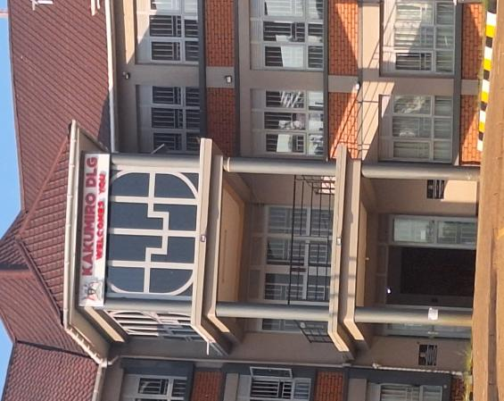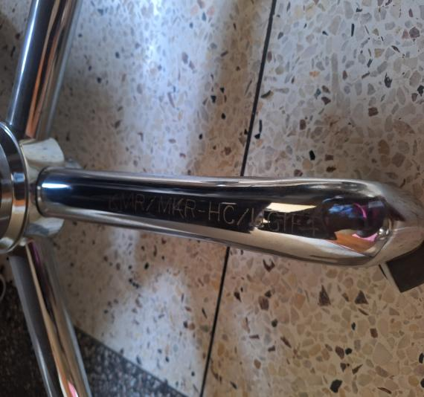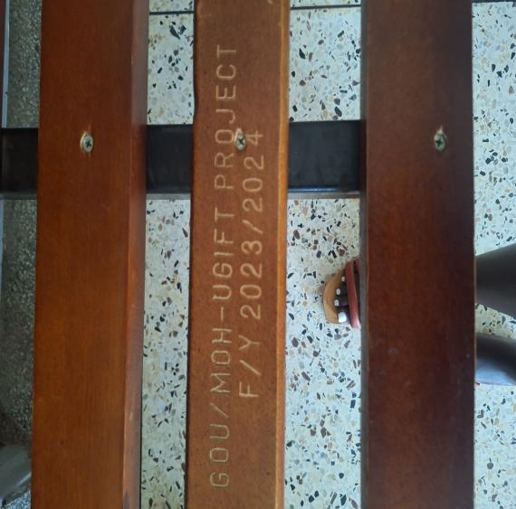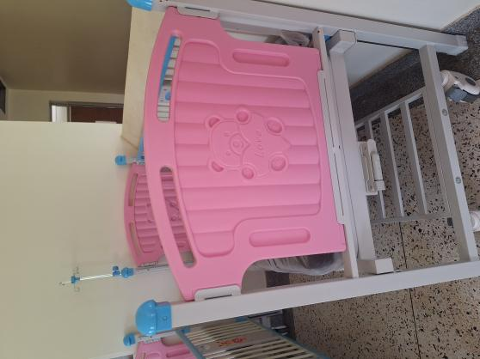
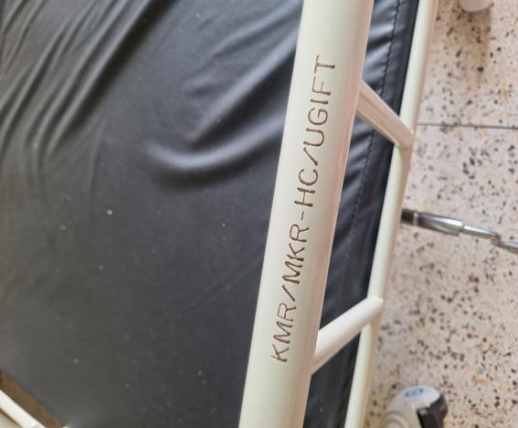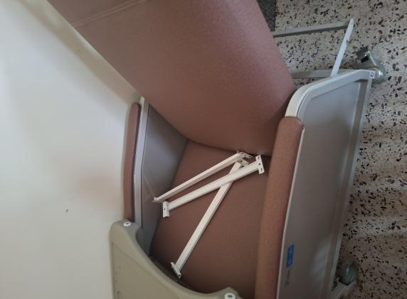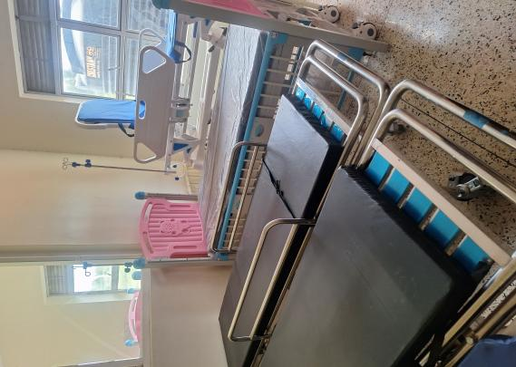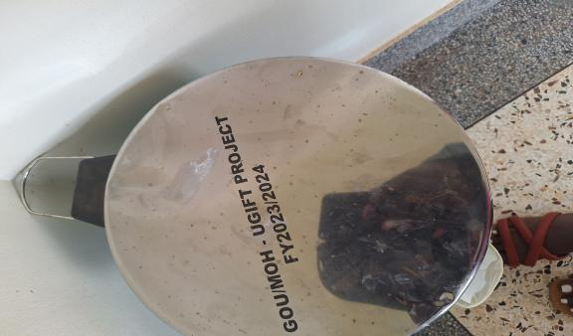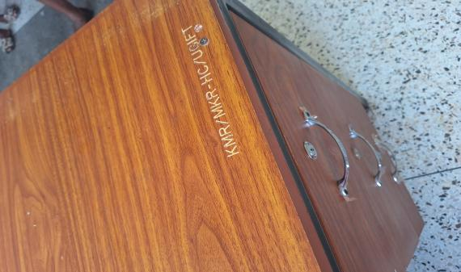
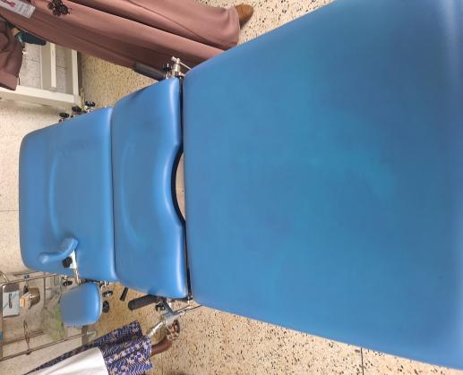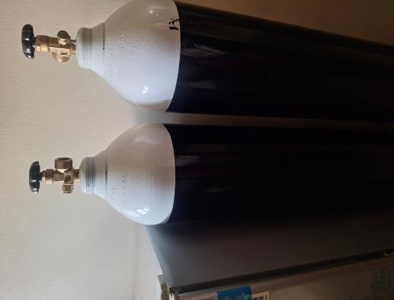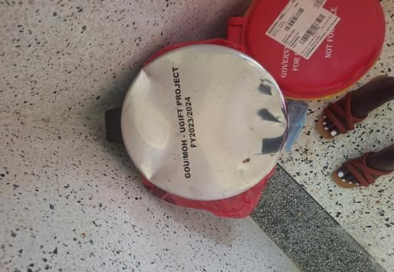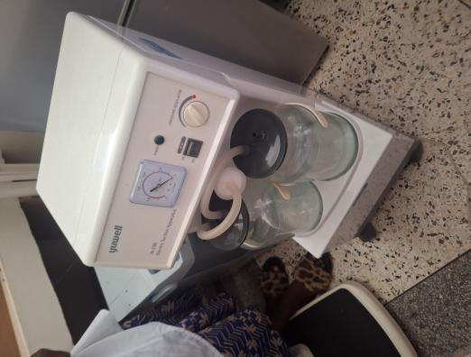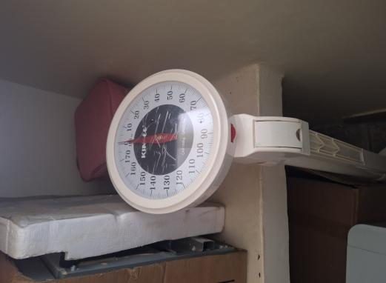
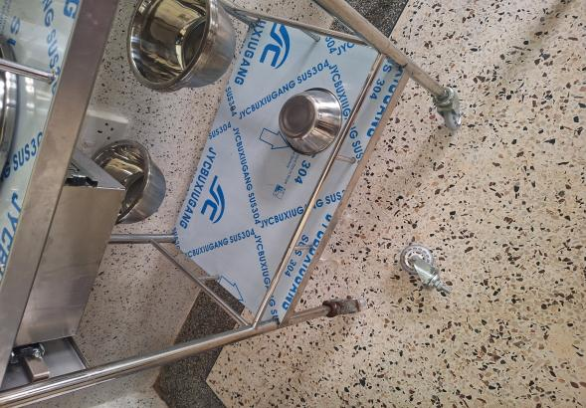

SCHOOL VERIFICATION CHECKLIST

SCHOOL INTERVIEW/DISCUSSION GUIDE

Name of school: ………………………………………………………………………………..

1a | Does the Facility have a record of all assets provided under UgIFT.  (Obtain a record and verify if it has the costs and numbers supplied
1b | If Not ask how many were supplied and when.

2 | How does this facility Maintain (repair/service/replace) the assets provided under Ugift

3 | Does the facility take regular record about functionality/ or breakdown of the assets provided?  Nonfunctional/ working, and reasons for non-functionality.

4 | How has the UgIFT support helped in service delivery in the area, any issues, challenges and any recommendations for better program implementation.

PROCEED TO VERIFICATION AFTER THIS DISCUSSION

SCHOOL FURNITURE
(School Desks, Office chairs, Laboratory stools, Book shelves)

Name of LG………………………………………………………………… Name of SCHOOL………………………………………………………………………………

Equipment/ Item | Department | Asset Number | Item  Description | Life in Months | Tag Number ( engrave no.) | Date Of Pur | Date Placed In Service | Recoverable cost | Cost | Acc Dep Cost | Net Book Value | Ytd Deprn | Equipment status | Remarks

ICT ITEMS TO VERIFY
(Desktop Computer, Server Processor, Network Switch 24 Port, Multipurpose Printer, UPS, Projector, Air Conditioners, Server, CCTV Camera)

Name of LG…………………………………………………………………………… Name of SCHOOL………………………….………………………………………

Equipment/ Item | Department | Asset Number | Item  Description | Life in Months | Tag Number ( engrave no.) | Date Of Pur | Date Placed In Service | Recoverable cost | Cost | Acc Dep Cost | Net Book Value | Ytd Deprn | Equipment status | Remarks

BUILDINGS TO VERIFY
(Non- Residential and Residential, Kitchen, Toilets/Pit latrine Water tanks, Fences etc.)

Name of LG…………………………………………………………………………… Name of SCHOOL………………………….………………………………………

Equipment/ Item | Department | Asset Number | Item  Description | Life in Months | Tag Number ( engrave no.) | Date Of Pur | Date Placed In Service | Recoverable cost | Cost | Acc Dep Cost | Net Book Value | Ytd Deprn | Equipment status | Remarks

